Task 3: SQL for Data Analysis
Objective: Use SQL queries to extract and analyze data from a database.
Code-
-- ECOMMERCE DATA ANALYSIS - COMPLETE SOLUTION

-- 1. CREATE TABLES
CREATE TABLE customers (
customer_id INT PRIMARY KEY AUTO_INCREMENT,
first_name VARCHAR(50),
last_name VARCHAR(50),
email VARCHAR(100),
city VARCHAR(50),
registration_date DATE
);

CREATE TABLE products (
product_id INT PRIMARY KEY AUTO_INCREMENT,
product_name VARCHAR(100),
category VARCHAR(50),
price DECIMAL(10,2),
stock_quantity INT
);

CREATE TABLE orders (
order_id INT PRIMARY KEY AUTO_INCREMENT,
customer_id INT,
order_date DATE,
total_amount DECIMAL(10,2),
status VARCHAR(20),
FOREIGN KEY (customer_id) REFERENCES customers(customer_id)
);

CREATE TABLE order_items (
order_item_id INT PRIMARY KEY AUTO_INCREMENT,
order_id INT,
product_id INT,
quantity INT,
unit_price DECIMAL(10,2),
FOREIGN KEY (order_id) REFERENCES orders(order_id),
FOREIGN KEY (product_id) REFERENCES products(product_id)
);

-- 2. INSERT SAMPLE DATA
INSERT INTO customers (first_name, last_name, email, city, registration_date) VALUES
('John', 'Doe', 'john.doe@email.com', 'New York', '2023-01-15'),
('Jane', 'Smith', 'jane.smith@email.com', 'Los Angeles', '2023-02-20'),
('Mike', 'Johnson', 'mike.johnson@email.com', 'Chicago', '2023-03-10'),
('Sarah', 'Wilson', 'sarah.wilson@email.com', 'New York', '2023-01-25'),
('David', 'Brown', 'david.brown@email.com', 'Miami', '2023-04-05'),
('Emily', 'Davis', 'emily.davis@email.com', 'Chicago', '2023-05-12');

INSERT INTO products (product_name, category, price, stock_quantity) VALUES
('Laptop', 'Electronics', 999.99, 50),
('Smartphone', 'Electronics', 699.99, 100),
('Headphones', 'Electronics', 149.99, 200),
('T-Shirt', 'Clothing', 29.99, 300),
('Jeans', 'Clothing', 59.99, 150),
('Book', 'Education', 19.99, 500),
('Coffee Mug', 'Home', 12.99, 250);

INSERT INTO orders (customer_id, order_date, total_amount, status) VALUES
(1, '2024-01-10', 1049.98, 'Delivered'),
(2, '2024-01-12', 769.98, 'Processing'),
(3, '2024-01-15', 179.98, 'Delivered'),
(1, '2024-01-20', 299.95, 'Shipped'),
(4, '2024-01-25', 129.97, 'Delivered'),
(5, '2024-02-01', 699.99, 'Processing'),
(6, '2024-02-05', 89.97, 'Delivered');

INSERT INTO order_items (order_id, product_id, quantity, unit_price) VALUES
(1, 1, 1, 999.99),
(1, 3, 1, 149.99),
(2, 2, 1, 699.99),
(2, 6, 1, 19.99),
(3, 4, 2, 29.99),
(3, 5, 2, 59.99),
(4, 4, 5, 29.99),
(5, 3, 1, 149.99),
(6, 2, 1, 699.99),
(7, 4, 3, 29.99);

-- 3. REQUIRED QUERIES:

-- a. SELECT, WHERE, ORDER BY, GROUP BY
-- Get customers from New York
SELECT first_name, last_name, email, registration_date
FROM customers
WHERE city = 'New York'
ORDER BY registration_date DESC;

-- Get expensive products
SELECT product_name, category, price
FROM products
WHERE price > 100
ORDER BY price DESC;

-- b. JOINS
-- INNER JOIN: Orders with customer details
SELECT
o.order_id,
c.first_name,
c.last_name,
o.order_date,
o.total_amount,
o.status
FROM orders o
INNER JOIN customers c ON o.customer_id = c.customer_id
ORDER BY o.order_date;

-- LEFT JOIN: All customers with their order counts
SELECT
c.customer_id,
c.first_name,
c.last_name,
COUNT(o.order_id) as order_count
FROM customers c
LEFT JOIN orders o ON c.customer_id = o.customer_id
GROUP BY c.customer_id, c.first_name, c.last_name;

-- RIGHT JOIN: All orders with customer info (even if customer deleted)
SELECT
o.order_id,
o.order_date,
o.total_amount,
COALESCE(c.first_name, 'Deleted') as first_name,
COALESCE(c.last_name, 'Customer') as last_name
FROM orders o
LEFT JOIN customers c ON o.customer_id = c.customer_id;

-- c. SUBQUERIES
-- Customers who spent more than average order value
SELECT
first_name,
last_name,
email,
(SELECT SUM(total_amount) FROM orders WHERE customer_id = c.customer_id) as total_spent
FROM customers c
WHERE (SELECT SUM(total_amount) FROM orders WHERE customer_id = c.customer_id) >
(SELECT AVG(total_amount) FROM orders);

-- Products never ordered
SELECT product_name, price, category
FROM products
WHERE product_id NOT IN (
SELECT DISTINCT product_id FROM order_items
);

-- d. AGGREGATE FUNCTIONS (SUM, AVG, COUNT, MAX, MIN)
-- Sales analysis by category
SELECT
category,
COUNT(*) as product_count,
AVG(price) as avg_price,
SUM(stock_quantity) as total_stock
FROM products
GROUP BY category;

-- Monthly sales summary
SELECT
MONTH(order_date) as month,
COUNT(*) as total_orders,
SUM(total_amount) as total_sales,
AVG(total_amount) as avg_order_value
FROM orders
GROUP BY MONTH(order_date)
ORDER BY month;

-- e. CREATE VIEW (FIXED SYNTAX)
-- Drop view if exists then create
DROP VIEW IF EXISTS customer_order_summary;

CREATE VIEW customer_order_summary AS
SELECT
c.customer_id,
c.first_name,
c.last_name,
c.city,
COUNT(o.order_id) as total_orders,
COALESCE(SUM(o.total_amount), 0) as total_spent,
COALESCE(AVG(o.total_amount), 0) as avg_order_value
FROM customers c
LEFT JOIN orders o ON c.customer_id = o.customer_id
GROUP BY c.customer_id, c.first_name, c.last_name, c.city;

-- Query the view
SELECT * FROM customer_order_summary ORDER BY total_spent DESC;

-- f. OPTIMIZE WITH INDEXES
CREATE INDEX idx_customers_city ON customers(city);
CREATE INDEX idx_orders_customer_id ON orders(customer_id);
CREATE INDEX idx_orders_order_date ON orders(order_date);
CREATE INDEX idx_products_category ON products(category);
CREATE INDEX idx_order_items_product_id ON order_items(product_id);

-- Verify indexes were created
SELECT TABLE_NAME, INDEX_NAME
FROM INFORMATION_SCHEMA.STATISTICS
WHERE TABLE_SCHEMA = DATABASE();

-- BONUS: Advanced analysis
-- Customer lifetime value by city
SELECT
c.city,
COUNT(DISTINCT c.customer_id) as total_customers,
COUNT(o.order_id) as total_orders,
SUM(o.total_amount) as total_revenue,
AVG(o.total_amount) as avg_order_value
FROM customers c
LEFT JOIN orders o ON c.customer_id = o.customer_id
GROUP BY c.city
ORDER BY total_revenue DESC;

-- Product performance
SELECT
p.product_name,
p.category,
COALESCE(SUM(oi.quantity), 0) as total_sold,
COALESCE(SUM(oi.quantity * oi.unit_price), 0) as total_revenue
FROM products p
LEFT JOIN order_items oi ON p.product_id = oi.product_id
GROUP BY p.product_id, p.product_name, p.category
ORDER BY total_revenue DESC;

OUTPUT:

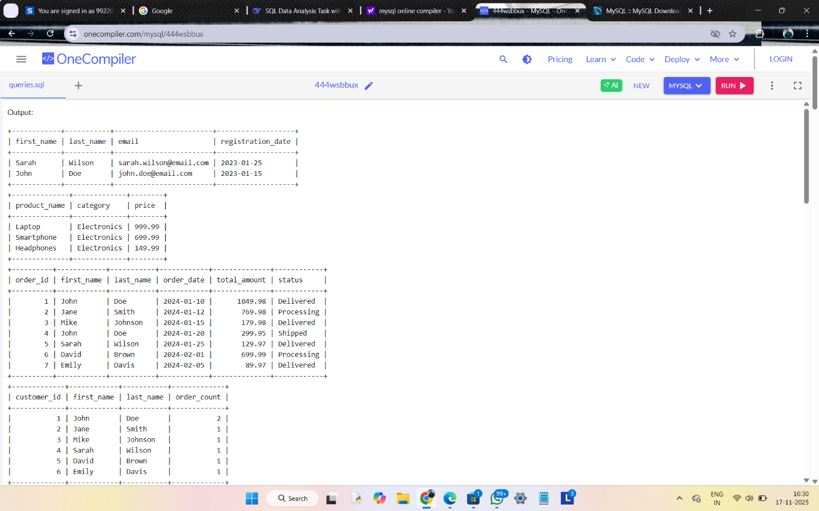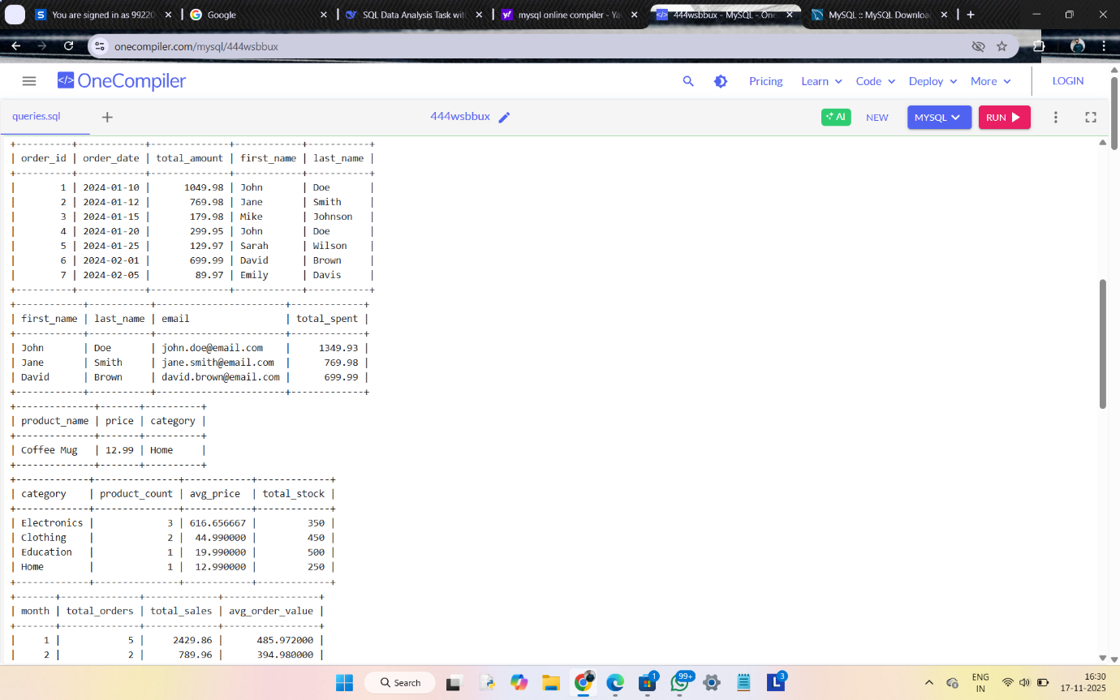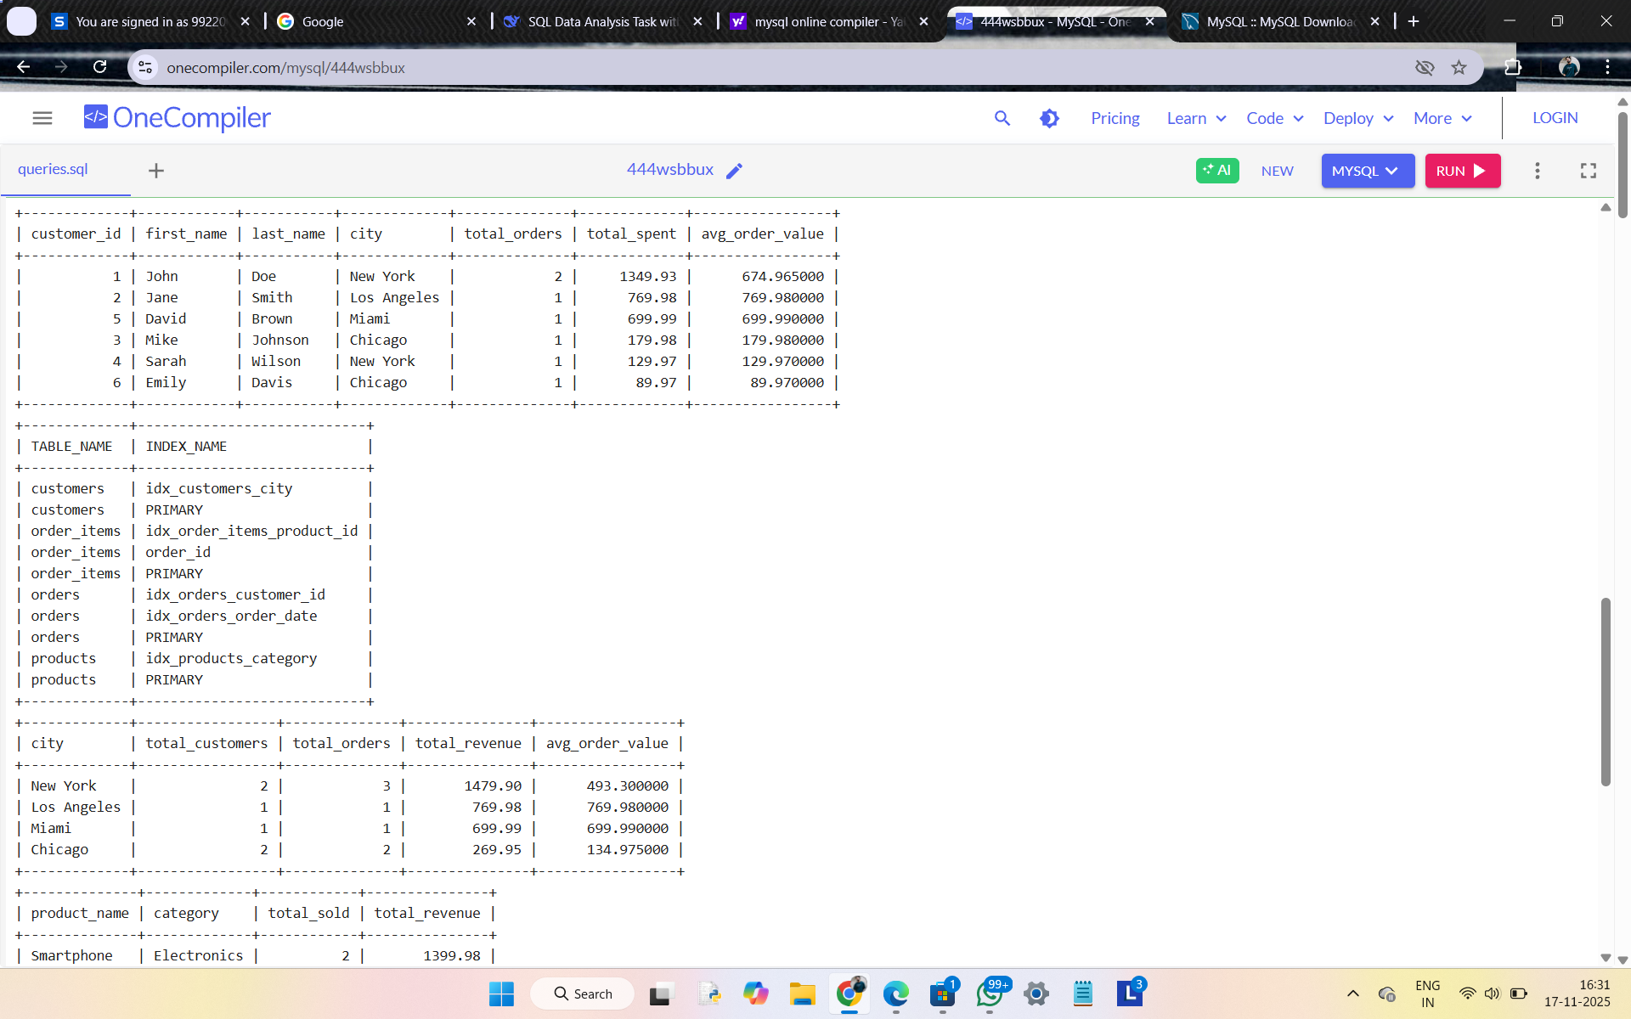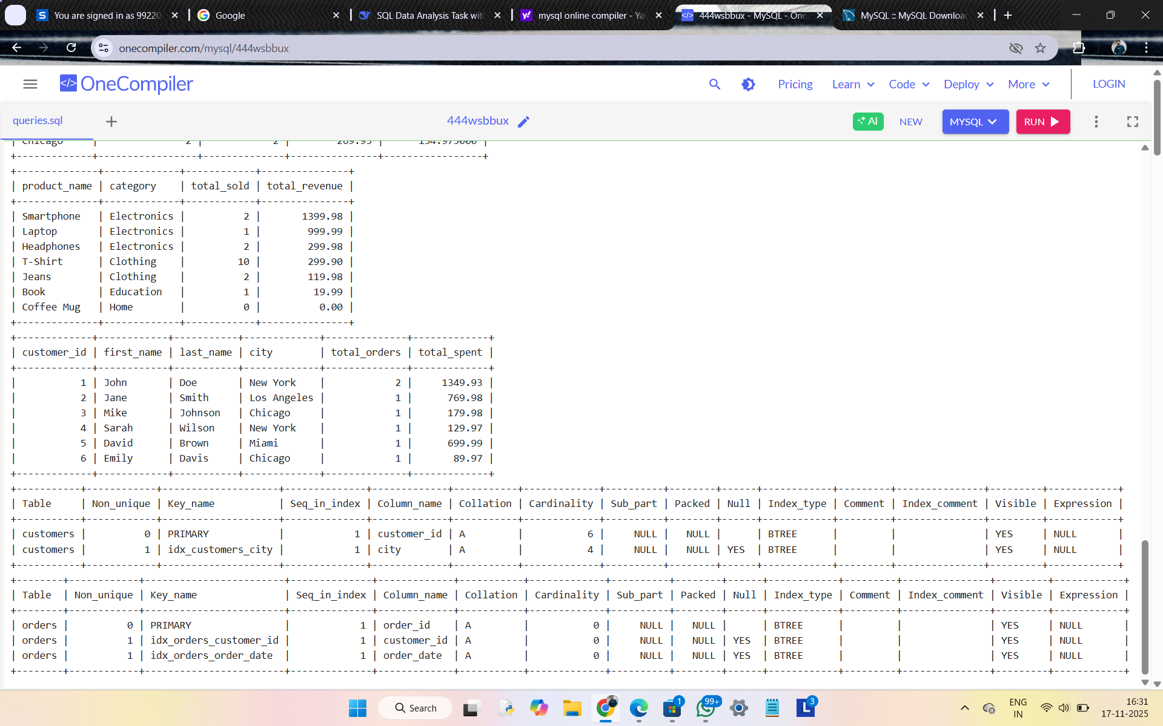

SHORT README:
Deliverables
- SQL File: ecommerce_analysis.sql with all queries
- Screenshots: 8 output screenshots demonstrating:
  - Basic SELECT operations
  - JOIN operations (INNER, LEFT, RIGHT)
  - Subqueries
  - Aggregate functions
  - Views creation
  - Index optimization
🎯 Skills Demonstrated
- ✅ SELECT, WHERE, ORDER BY, GROUP BY
- ✅ JOINS (INNER, LEFT, RIGHT)
- ✅ Subqueries for complex analysis
- ✅ Aggregate functions (SUM, AVG, COUNT)
- ✅ Views for simplified data access
- ✅ Indexes for query optimization
📊 Analysis Performed
- Customer segmentation by city
- Sales performance by category
- Monthly revenue analysis
- Customer spending patterns
- Product performance metrics
🚀 Outcome
Successfully extracted, manipulated, and analyzed structured data using SQL, demonstrating proficiency in database querying and optimization techniques.

